CHAPTER 8: The dynamic Earth
© MAPgraphics Pty Ltd, Brisbane
Worksheet 8.6

Volcanic activity
Student: Class:

Steep-sided volcanoes
1. The diagram shows a steep-sided volcano forming as a result of tectonic activity.
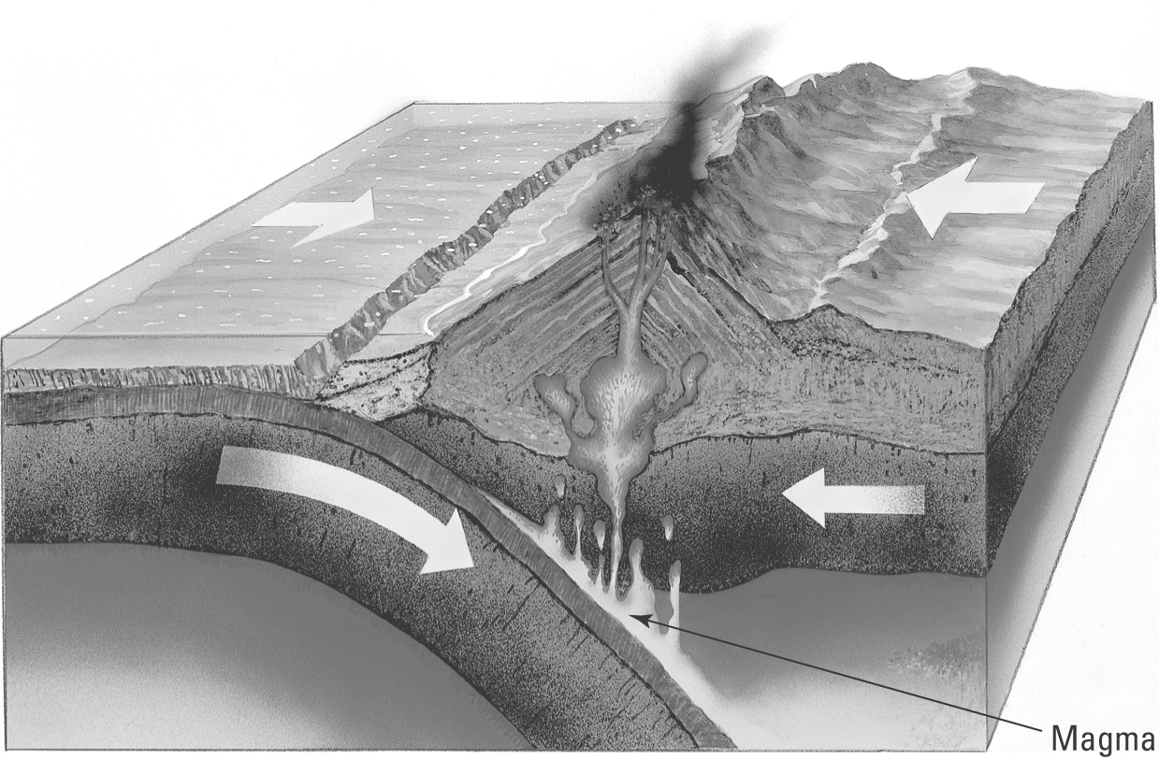 | (a) Identify the type of plate boundary that leads to the formation of the volcano.  (b) Explain why the oceanic crust melts to form magma.  (c) Identify a location in the southern hemisphere where such an event occurs.

Eruption
2. The following events describe the eruption of a steep-sided volcano. The events are jumbled. Rearrange the letters A–F to arrange the events in the correct sequence.
A. Magma rises towards the surface.
B. Lava is blasted into the air.
C. The expanding gases cause an explosion that rips open the vent.
D. Ash, cinders and dust rain down onto the ground.
E. Low-density magma rises under pressure into the magma chamber.
F. Dissolved gases expand as the magma rises.
Answer:
Our volcanic neighbours  3. The diagram below shows the region north and east of Australia. Volcanoes are marked on the map.  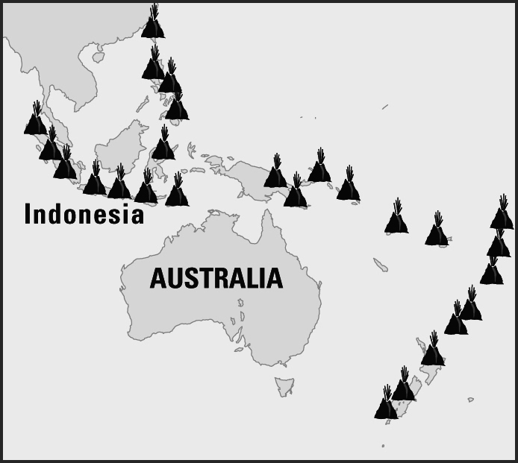 | (a) Explain why the volcanoes are located in these places.  (b) Explain why there are no active volcanoes in Australia.

